From the web page, Multiple hyperlinks and multiple submit buttons can generate requests to same servlet.

Q) How does servlet differentiate requests?

A) give same name to all submit buttons with different captions and give additional parameter to hyperlink but make sure that name of additional parameter must match with the name of submit buttons.

Example:-

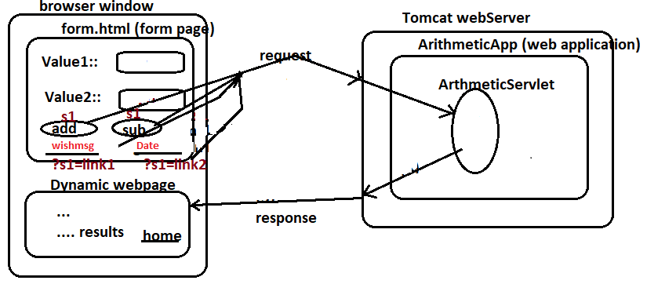

Example:-

FileName: index.html

<!DOCTYPE html>

<html>

<head>

<meta charset="UTF-8">

<title>Insert title here</title>

</head>

<body>

<form action="ArithmeticServ1" method="GET">

FirstNumber:<input type="text" name="n1"><br>

SecondNumber:<input type="text" name="n2"><br>

<input type="submit" name="s1" value="add">&nbsp;&nbsp;

<input type="submit" name="s1" value="sub">

</form>

<a href="ArithmeticServ1?s1=msg"> Wish Message</a>

<a href="ArithmeticServ1?s1=dt"> Today date</a>

</body>

</html>

FileName:ArithmeticServ1.java

**package** com.sgc.suku;

**import** java.io.IOException;

**import** java.io.PrintWriter;

**import** java.time.LocalDate;

**import** jakarta.servlet.ServletException;

**import** jakarta.servlet.http.HttpServlet;

**import** jakarta.servlet.http.HttpServletRequest;

**import** jakarta.servlet.http.HttpServletResponse;

**public** **class** ArithmeticServ1 **extends** HttpServlet {

**private** **static** **final** **long** ***serialVersionUID*** = 1L;

**public** ArithmeticServ1() {

}

**protected** **void** doGet(HttpServletRequest req, HttpServletResponse res) **throws** ServletException, IOException {

res.setContentType("text/html");

PrintWriter pw=res.getWriter();

String s=req.getParameter("s1");

System.***out***.print(s);

**int** c=0;

**if**(s.equalsIgnoreCase("add")) {

**int** num1=Integer.*parseInt*(req.getParameter("n1"));

**int** num2=Integer.*parseInt*(req.getParameter("n2"));

c=num1+num2;

pw.print("<h2>sum:"+c+"</h2>");

}

**else** **if**(s.equalsIgnoreCase("sub")) {

**int** num1=Integer.*parseInt*(req.getParameter("n1"));

**int** num2=Integer.*parseInt*(req.getParameter("n2"));

c=num1-num2;

pw.print("<h2>Difference:"+c+"</h2>");

}

**else** **if**(s.equalsIgnoreCase("msg")) {

pw.print("<h2>Hai sukumar</h2>");

}

**else** {

LocalDate d=LocalDate.*now*();

pw.print("<h2>Today Date:"+d+"</h2>");

}

pw.close();

}

}

FileName:Web.xml

<web-app xmlns:xsi=*"http://www.w3.org/2001/XMLSchema-instance"* xmlns=*"http://xmlns.jcp.org/xml/ns/javaee"* xsi:schemaLocation=*"http://xmlns.jcp.org/xml/ns/javaee http://xmlns.jcp.org/xml/ns/javaee/web-app_4_0.xsd"* id=*"WebApp_ID"* version=*"4.0"*>

<display-name>ArithmeticApp-1</display-name>

<welcome-file-list>

<welcome-file>index.html</welcome-file>

</welcome-file-list>

<servlet>

<servlet-name>ArithmeticServ1</servlet-name>

<servlet-class>com.sgc.suku.ArithmeticServ1</servlet-class>

</servlet>

<servlet-mapping>

<servlet-name>ArithmeticServ1</servlet-name>

<url-pattern>/ArithmeticServ1</url-pattern>

</servlet-mapping>

<welcome-file-list>

<welcome-file>index.html</welcome-file>

</welcome-file-list>

</web-app>

Project Directory Structure

